**Screenshots**:-   
  
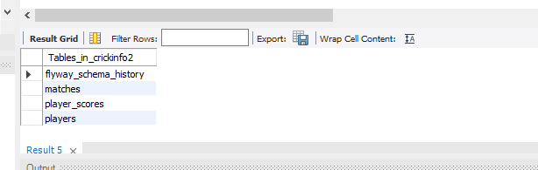

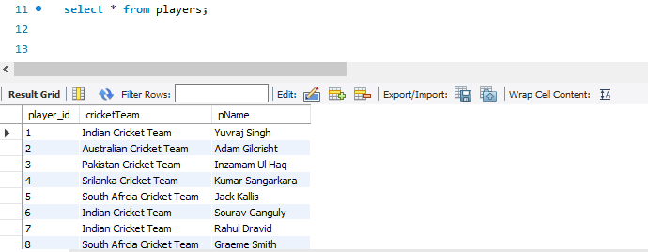**The tables inside the schema**

**Player details table**

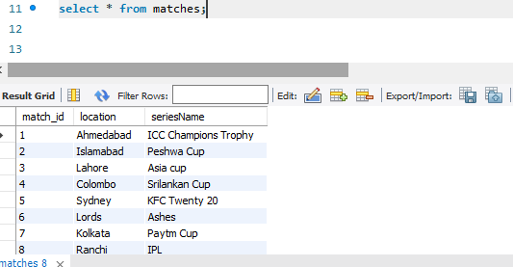

**Match details table**

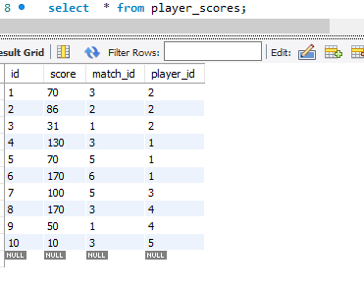

**Player score table**

**TABLE CONSTRUCTION:-   
  
Player to Score (One to Many)  
Match to Score(One to Many)  
Score to Player and Match(Many to One)**